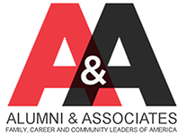
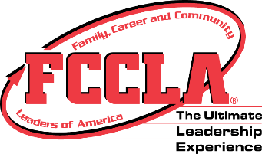
KY Alumni & Associates
cordially invites you to the inaugural
Kentucky FCCLA Homecoming: Where Your Story Began
Friday, November 16, 2018
6:00 PM – 10:00 PM
Keene Trace Golf Club - Champion Trace Course Ballroom
20 Avenue of Champions
Nicholasville, KY 40356
6:00 p.m. Cocktail Hour & Silent Auction
7:00 p.m. Welcome & Dinner
Introduction of Special Guests
Former State Officer Recognition
Where Your Story Began Program
Closing Remarks

Join us for an evening of dinner, dancing, and fellowship!
Semi-formal attire is requested.

For further information or questions, please contact Kayla Godbey, KY FCCLA Advisory Board Chairperson
kayla.godbey@education.ky.gov or 502.564.3472

